**Megha Sharma**

**Pavani Sree Lakshmi Penumathsa**

**Reshma Reddy Thumma**

**Vinutha Nuchimaniyanda**

**Project Report Recipe Search Application**

**Increment-2**

CS-5551 ASE

We have been able to implement the following features as part of the first and second increment of the project.

1. Home screen for the user to enter all the ingredients.
2. Interface screen to show the results for the entered combination of recipes.
3. Collected all the RDF datasets for recipe from the internet using web crawler.
4. We have classified datasets using naïve-base algorithm in mahout.
5. Pushed this classified data into solr.

**Web Client/Mobile UI Design**

To design the UI, we have used android API, open source images, android default spinner and number picker widgets.

**System Architecture Diagram**

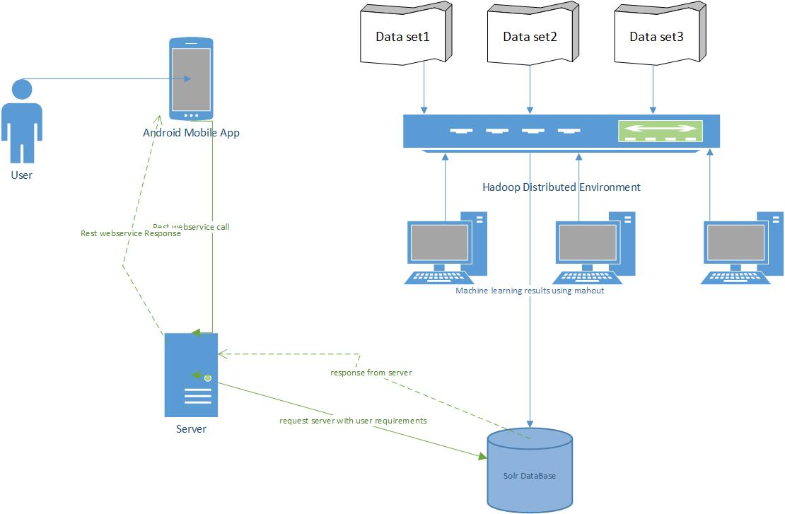

**Class Diagram**

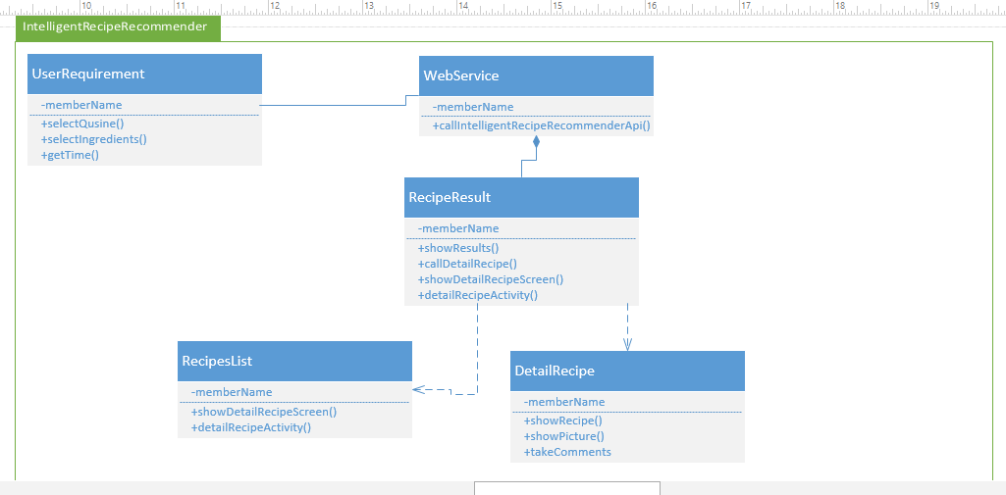

**Sequence Diagrams**



**Implementation Details**

The details of the features are below:

**Webservices/API:**

* We have used android app in order to make the home screen where the user can enter the ingredients which he have, time for making the recipe, what kind of cuisine and what kind of meal and after that we also created an android API for the result screen where we will show what kind of recipe he can make.
* **Design & Implementation details:**

Splash screen for android app

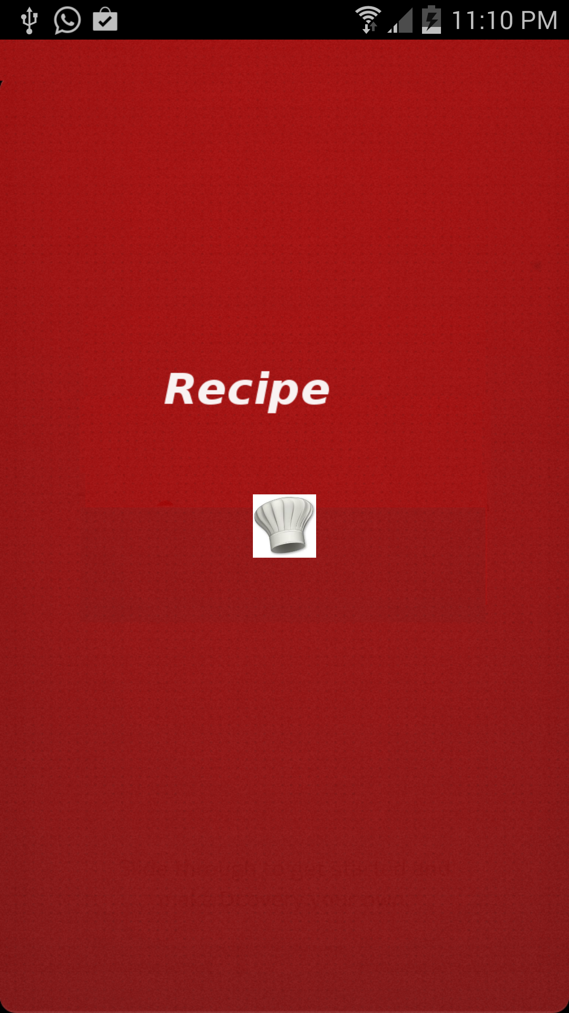

We will launch our application by clicking app icon from launcher



Screen shots for home screen of recipe recommender where we will take input from the user.

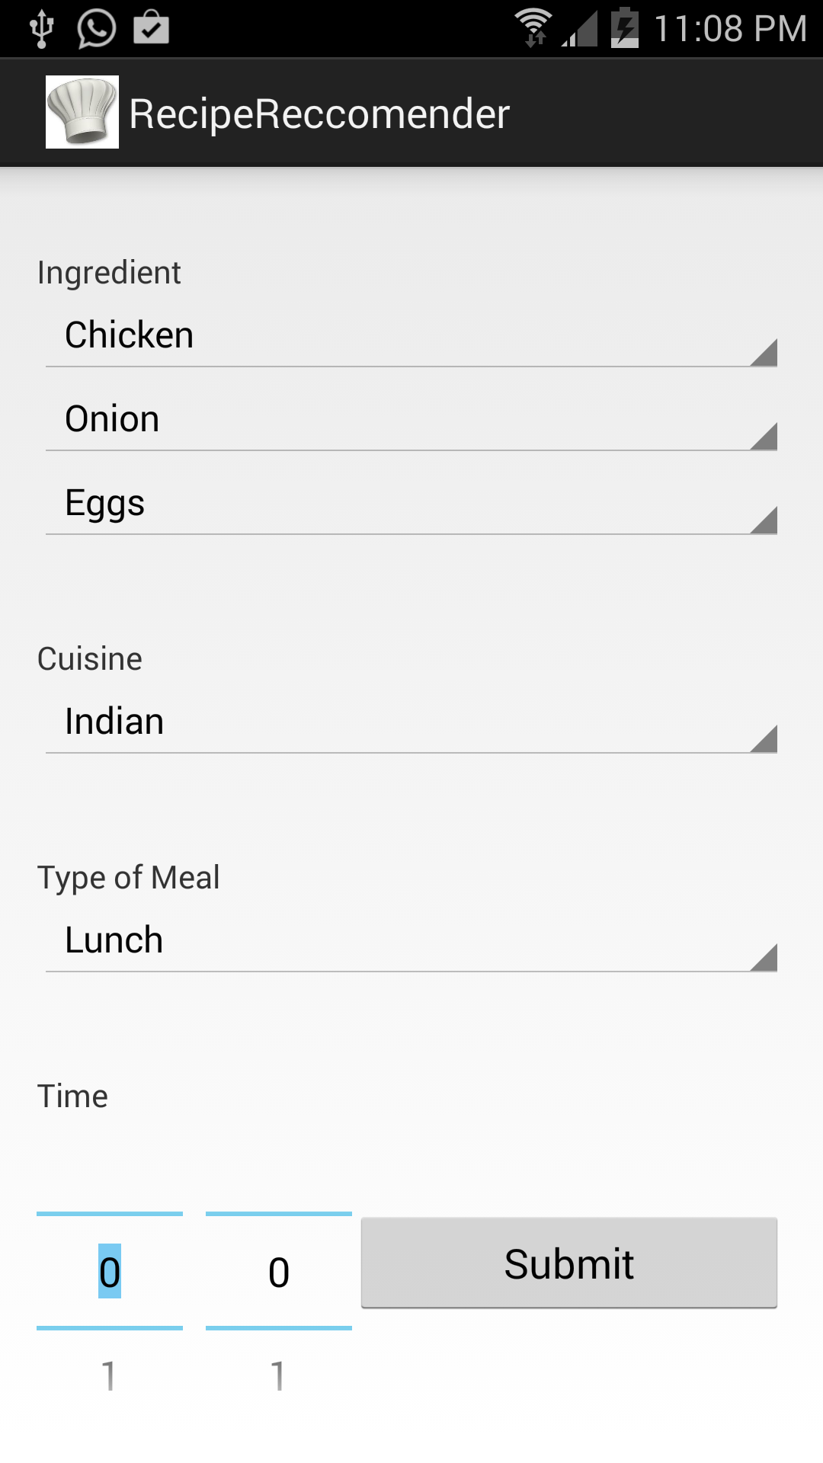

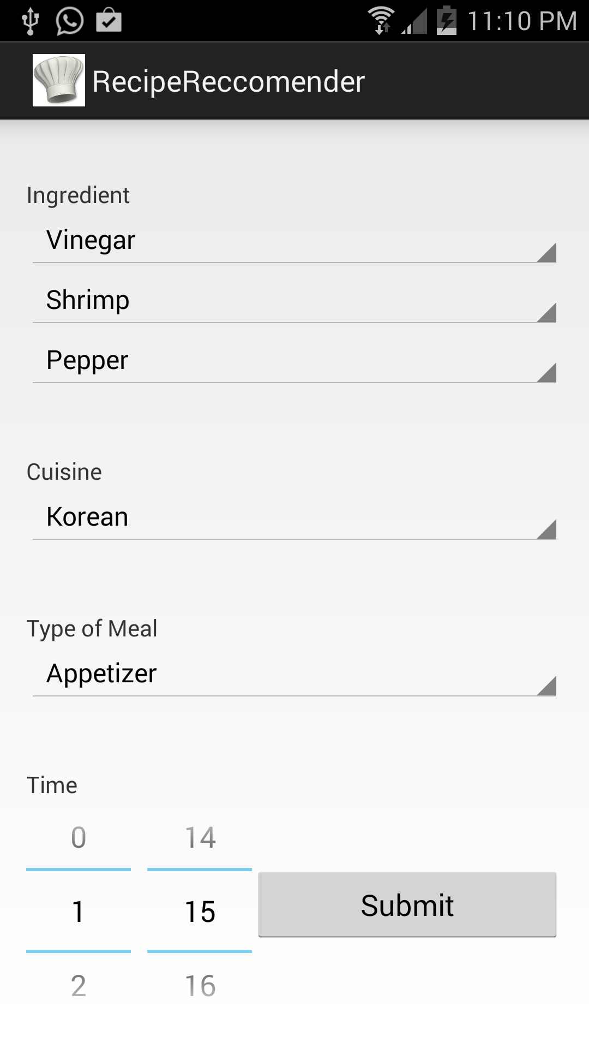

Screen shot for data sets

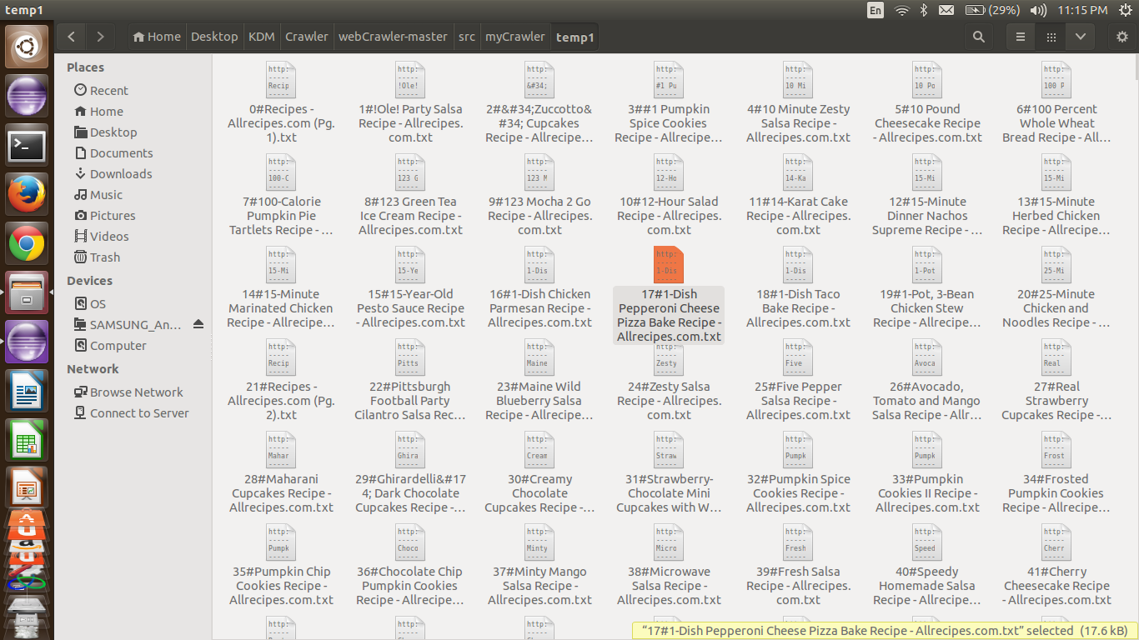

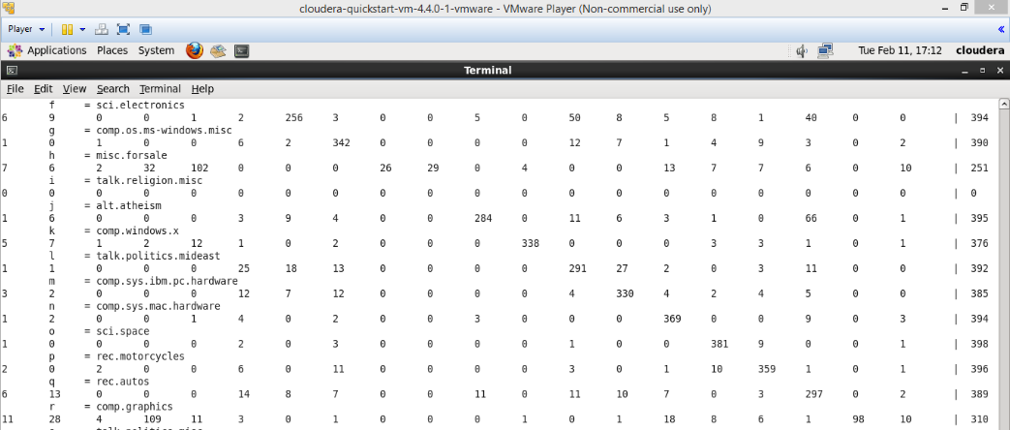

**Git Hub Repository:**

<https://github.com/varunnarisetty/KDM_CS5560/tree/master/Recipe_project/Increment2>

**ScrumDo:**

<https://www.scrumdo.com/projects/project/recipe-recommendation/summary>